Task 1: Design and Populate a Restaurant Database

Q1). Create a database named foodapp_db and a table named restaurants with columns: restaurant_id (INT, AUTO_INCREMENT, PRIMARY KEY), name (VARCHAR, NOT NULL), city (VARCHAR), cuisine_type (VARCHAR), and rating (DECIMAL(3,1)).
Query:-
create database foodapp_db;
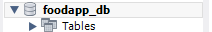
create table restaurants (restaurant_id int primary key auto_increment, name varchar(30) not null,city varchar(30),cuisine_type varchar(30),rating decimal (3,1)); 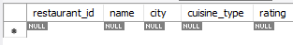
Q2).Insert at least 6 restaurant records spanning at least 3 different cities.
Query:-
INSERT INTO restaurants (name, city, cuisine_type, rating) VALUES
('Spice Garden', 'Surat', 'Indian', 4.5),
('Royal Biryani', 'Ahmedabad', 'Mughlai', 4.2),
('Pizza Hub', 'Mumbai', 'Italian', 4.0),
('Green Leaf', 'Surat', 'Vegetarian', 4.7),
('Taste of Punjab', 'Delhi', 'Punjabi', 4.3),
('Urban Tadka', 'Ahmedabad', 'North Indian', 4.1);
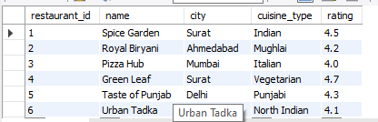

Q3). Update the rating of one restaurant and delete one restaurant record using a WHERE condition.
Query:-
update restaurants set rating=3.8 where name='Urban Tadka';
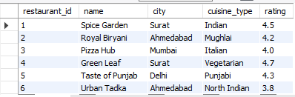
delete from restaurants where name='Royal Biryani';
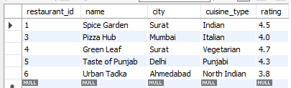

Q4). Write a SELECT query that retrieves all restaurants sorted by rating in descending order.
Query:-
SELECT * FROM foodapp_db.restaurants order by rating desc; 